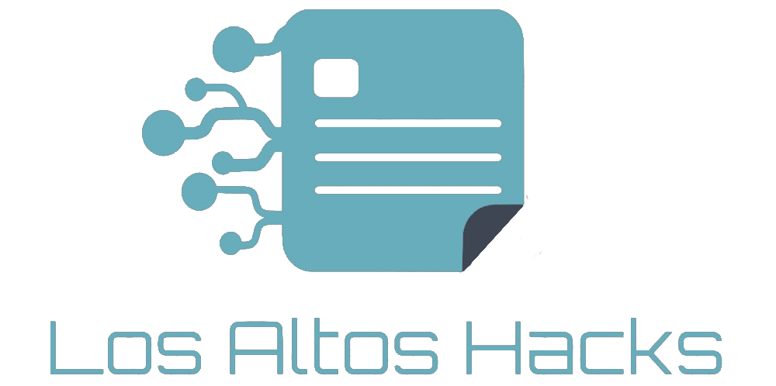

What is Los Altos Hacks?

Los Altos Hacks is a student-run hackathon targeted at high school students in the Bay Area. It aims to be an all-inclusive event that allows students to express their creativity and eliminate the social obstacles surrounding programming. We hope to convince others that anyone can learn to code: Programming is not solely for boys or geniuses. The hackathon will offer an environment focused on increasing diversity in the field of computer science. Furthermore, sponsors will have the opportunity to send mentors, present APIs, and evangelize their brands. What are the logistics of Los Altos Hacks?

We plan to host approximately 200 students with varying amounts of experience in computer science. Los Altos Hacks will take place at the Hillview Community Center, which is located at 97

Hillview Avenue in Los Altos, California. It will occur from January 30 to January 31, 2016. Mentors and sponsors can come in starting at 9:30 AM on the 30th, while students can begin registering at 11 AM, and the event will end at 4 PM on the 31st.

Why sponsor Los Altos Hacks?

Although a high school hackathon may not offer the same recruiting options as a collegiate hackathon, sponsors will still be able to form valuable relationships with the programmers of the future. Because many participants of high school hackathons are first time coders, your company will make an impactful first impression and consequently have a greater influence on

the languages and tools that these coders learn. With this opportunity to reach out and advertise to young adults, representatives from your company will also be able to increase its leverage

and consumer base.

Where will your money go?

Your money will help cover the expenses of food, t-shirts, a venue, swag, emergency equipment, as well as any other costs to make Los Altos Hacks the best it can be.

How can you help?

• Donate money directly to the organization—this will give us the flexibility to ensure that all needs are fully catered for.

• Sponsor a meal—we will serve a total of four meals over the entire course of the hackathon.

• Send an evangelist or engineer down to mentor and inspire students.

• Provide students with tools to use during the event (i.e., hosting, hardware).

• If you have any other ideas, questions, or concerns, please do not hesitate to contact us at [sponsor@losaltoshacks.com](mailto:sponsor@losaltoshacks.com).

Sponsorship Tiers

Bronze

$1k

|  |  |
| --- | --- |
|  |  |
| General  Send engineers and mentors Initial API/Product Demo Award Custom Prizes Sponsor Table Workshop/Tech Talk  Recruiting  Distribute Recruiting Materials  Send Recruiters  Access to Resumes/Githubs  Interviews During Event  Branding  Logo on Website Logo on T-Shirt Company Banners Swag  Presentation at Awards Ceremony |  |
| x x x x |
| 1 min 2 min 3 min Keynote |
| x x x x |
| x x x |
| 1 2 5 |
|  |
| x x x x |
| x x x |
| x x |
| x |
|  |
| x x x x |
| x x x |
| x x x |
| x x x |
| x |

Silver

$2k

Gold

$3k

Partner

$5k

Interested?

Please contact us at [sponsor@losaltoshacks.com](mailto:sponsor@losaltoshacks.com) if you are interested. All sponsorships are negotiable and can be discussed in more detail. If these tiers are not suitable, please contact us for more information.